## **ASSIGNMENT**

## **ON**

## JSP JDBC MySQL

**COURSE NAME: ADVANCE ENTERPRISE JAVA (LAB)**

**COURSE CODE: SE 410**

SUBMITTED TO:

MD. SAFAET HOSSAIN

ASSOCIATE PROFESSOR AND HEAD

DEPARTMENT OF CSE

SUBMITTED BY:

ZULKAR NINE

163432601

SAJEDUL ISLAM

163432559

43RD BATCH

DEPARTMENT OF CSE

SUBMITTED DATE: 30-11-2020

Java Server Pages (JSP) is a server-side programming technology that enables the creation of dynamic, platform-independent method for building Web-based applications. JSP have access to the entire family of Java APIs, including the JDBC API to access enterprise databases.

**Insert data**

**index.jsp**

<%@page contentType="text/html" pageEncoding="UTF-8"%>

<!DOCTYPE html>

<html>

<head>

<meta http-equiv="Content-Type" content="text/html; charset=UTF-8">

<title>JSP Page</title>

</head>

<body style="background-color: yellow">

<div style="text-align: center;">

<h1 style="color: green">Insert Data Form</h1>

<form method="post" action="process.jsp" >

First name:<br>

<input type="text" name="first_name">

<br>

Last name:<br>

<input type="text" name="last_name">

<br>

City name:<br>

<input type="text" name="city_name">

<br>

Email Id:<br>

<input type="email" name="email">

<br><br>

<input type="submit" value="submit">

</form>

</div>

</body>

</html>

**output:**

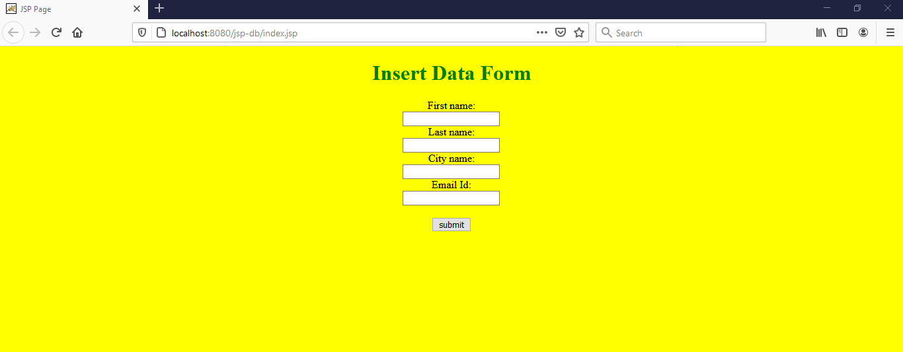

**process.jsp**

<%@page contentType="text/html" pageEncoding="UTF-8"%>

<%@page import ="java.sql.*" %>

<!DOCTYPE html>

<html>

<head>

<meta http-equiv="Content-Type" content="text/html; charset=UTF-8">

<title>JSP Page</title>

</head>

<body>

<%

String first_name=request.getParameter("first_name");

String last_name=request.getParameter("last_name");

String city_name=request.getParameter("city_name");

String email=request.getParameter("email");

try

{

Class.forName("com.mysql.jdbc.Driver");

Connection conn = DriverManager.getConnection("jdbc:mysql://localhost:3306/jspdb", "root", "");

Statement st=conn.createStatement();

int i=st.executeUpdate("insert into users(first_name,last_name,city_name,email)values('"+first_name+"','"+last_name+"','"+city_name+"','"+email+"')");

out.println("Data is successfully inserted!");

//out.print("<a href="retrieve.jsp">show details</a>");

}

catch(Exception e)

{

System.out.print(e);

e.printStackTrace();

}

%>

<br>

<a href="index.jsp">Insert More</a>

<br>

<a href="retrieve.jsp">show details</a>

</body>

</html>

**output:**

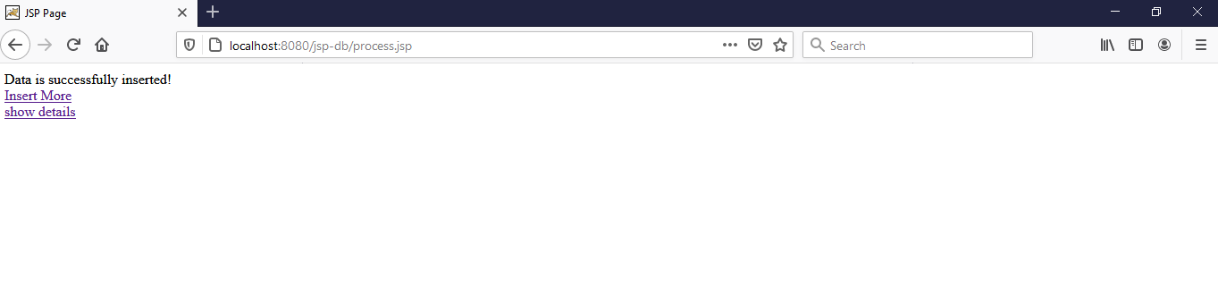

**Read data**

**retrieve.jsp**

<%@page import="java.sql.DriverManager"%>

<%@page import="java.sql.ResultSet"%>

<%@page import="java.sql.Statement"%>

<%@page import="java.sql.Connection"%>

<%

//String id = request.getParameter("userid");

String driver = "com.mysql.jdbc.Driver";

String connectionUrl = "jdbc:mysql://localhost:3306/";

String database = "jspdb";

String userid = "root";

String password = "";

try {

Class.forName(driver);

} catch (ClassNotFoundException e) {

e.printStackTrace();

}

Connection connection = null;

Statement statement = null;

ResultSet resultSet = null;

%>

<!DOCTYPE html>

<html>

<body>

<h1>Retrieve data from database in jsp</h1>

<table border="1">

<tr>

<td>first name</td>

<td>last name</td>

<td>City name</td>

<td>Email</td>

<td>Action</td>

</tr>

<%

try{

connection = DriverManager.getConnection(connectionUrl+database, userid, password);

statement=connection.createStatement();

String sql ="select * from users";

resultSet = statement.executeQuery(sql);

while(resultSet.next()){

%>

<tr>

<td><%=resultSet.getString("first_name") %></td>

<td><%=resultSet.getString("last_name") %></td>

<td><%=resultSet.getString("city_name") %></td>

<td><%=resultSet.getString("email") %></td>

<td><a href="update.jsp?id=<%=resultSet.getString("id") %>">UPDATE</a></td>

<td><a href="delete.jsp?id=<%=resultSet.getString("id") %>">DELETE</a></td>

</tr>

<%

}

connection.close();

} catch (Exception e) {

e.printStackTrace();

}

%>

</table>

</body>

</html>

**output:**

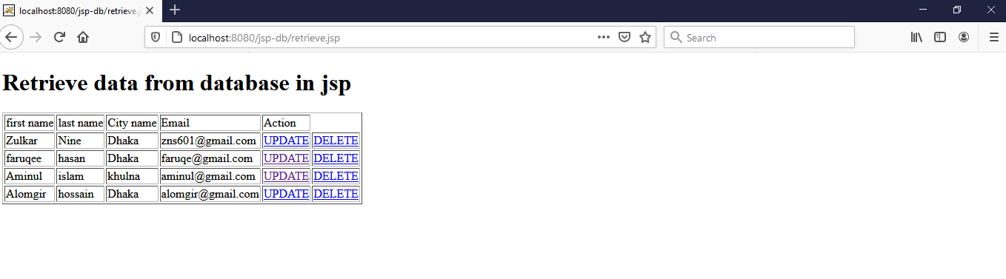

**Delete data**

**delete.jsp**

<%@page contentType="text/html" pageEncoding="UTF-8"%>

<!DOCTYPE html>

<html>

<head>

<meta http-equiv="Content-Type" content="text/html; charset=UTF-8">

<%@page import ="java.sql.*" %>

<title>JSP Page</title>

</head>

<body>

<%

String id=request.getParameter("id");

try

{

Class.forName("com.mysql.jdbc.Driver");

Connection conn = DriverManager.getConnection("jdbc:mysql://localhost:3306/jspdb", "root", "");

Statement st=conn.createStatement();

int i=st.executeUpdate("DELETE FROM users WHERE id="+id);

out.println("Data Deleted Successfully!");

}

catch(Exception e)

{

System.out.print(e);

e.printStackTrace();

}

%>

<a href="retrieve.jsp">show details</a>

</body>

</html>

**output:**

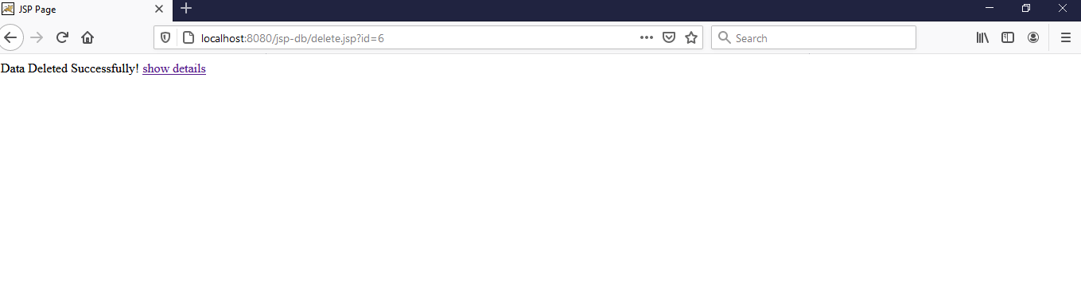

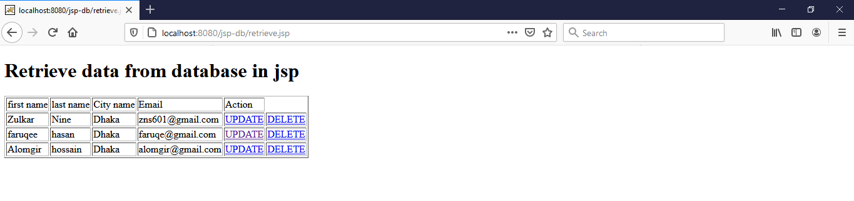

**Update data**

**update.jsp**

<%@page import="java.sql.DriverManager"%>

<%@page import="java.sql.ResultSet"%>

<%@page import="java.sql.Statement"%>

<%@page import="java.sql.Connection"%>

<%

String id = request.getParameter("id");

String driver = "com.mysql.jdbc.Driver";

String connectionUrl = "jdbc:mysql://localhost:3306/";

String database = "jspdb";

String userid = "root";

String password = "";

try {

Class.forName(driver);

} catch (ClassNotFoundException e) {

e.printStackTrace();

}

Connection connection = null;

Statement statement = null;

ResultSet resultSet = null;

%>

<%

try{

connection = DriverManager.getConnection(connectionUrl+database, userid, password);

statement=connection.createStatement();

String sql ="select * from users where id="+id;

resultSet = statement.executeQuery(sql);

while(resultSet.next()){

%>

<!DOCTYPE html>

<html>

<body style="background-color: yellow">

<div style="text-align: center;">

<h1>Update data from database in jsp</h1>

<form method="post" action="update-process.jsp">

<input type="hidden" name="id" value="<%=resultSet.getString("id") %>">

<input type="text" name="id" value="<%=resultSet.getString("id") %>" readonly="">

<br>

First name:<br>

<input type="text" name="first_name" value="<%=resultSet.getString("first_name") %>">

<br>

Last name:<br>

<input type="text" name="last_name" value="<%=resultSet.getString("last_name") %>">

<br>

City name:<br>

<input type="text" name="city_name" value="<%=resultSet.getString("city_name") %>">

<br>

Email Id:<br>

<input type="email" name="email" value="<%=resultSet.getString("email") %>">

<br><br>

<input type="submit" value="submit">

</form>

<%

}

connection.close();

} catch (Exception e) {

e.printStackTrace();

}

%>

</div>

</body>

</html>

**output:**

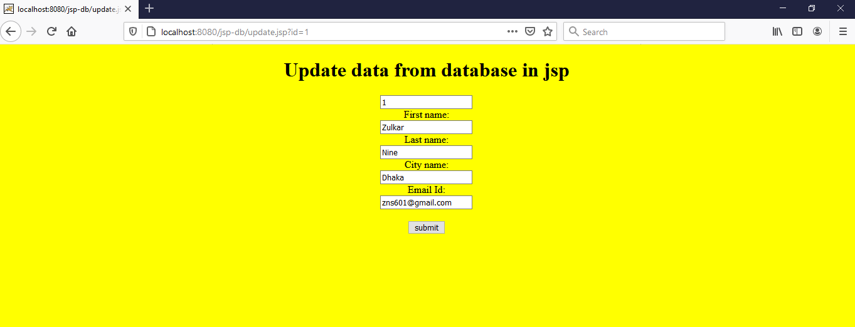

**update-process.jsp**

<%@ page language="java" contentType="text/html; charset=ISO-8859-1" pageEncoding="ISO-8859-1"%>

<%@ page import="java.sql.*" %>

<%! String driverName = "com.mysql.jdbc.Driver";%>

<%!String url = "jdbc:mysql://localhost:3306/jspdb";%>

<%!String user = "root";%>

<%!String psw = "";%>

<%

String id = request.getParameter("id");

String first_name=request.getParameter("first_name");

String last_name=request.getParameter("last_name");

String city_name=request.getParameter("city_name");

String email=request.getParameter("email");

if(id != null)

{

Connection con = null;

PreparedStatement ps = null;

int personID = Integer.parseInt(id);

try

{

Class.forName("com.mysql.jdbc.Driver");

con = DriverManager.getConnection(url,user,psw);

String sql="Update users set id=?,first_name=?,last_name=?,city_name=?,email=? where id="+id;

ps = con.prepareStatement(sql);

ps.setString(1,id);

ps.setString(2, first_name);

ps.setString(3, last_name);

ps.setString(4, city_name);

ps.setString(5, email);

int i = ps.executeUpdate();

if(i > 0)

{

out.print("Record Updated Successfully");

}

else

{

out.print("There is a problem in updating Record.");

}

}

catch(SQLException sql)

{

request.setAttribute("error", sql);

out.println(sql);

}

}

%>

<a href="retrieve.jsp">Show details</a>

**output:**

